Screening Guide for Veterans
Welcome to the Screening Guide for Veterans. This guide is intended to support organizational development of screening and interventions for trauma-informed care (TIC) and to provide clear direction for what staff should do, not just what to avoid. Interventions should support meaningful, consistent relationships with the spirit of “Let’s find solutions together” instead of “We, the ‘staff’ or ‘the IDT’, know best”. Interventions should provide individualized information about how staff can help the individual meet an unmet need as well as continue to enhance needs that are being met.
An important premise is that this guide has been created with the expectation that the organization has begun the journey to adopt trauma-informed care including staff training. The intention is to support staff who are trained in a trauma-informed care approach and demonstrate that skillset. For staff that have not received TIC training or for whom TIC is not in their scope of practice, this guide can serve as a resource to find information and learn about training options. NHPCO’s Trauma-Informed End-of-Life Care Work Group’s Tools and Resources page and the We Honor Veterans Trauma-Informed Care for Veterans Resource page are excellent resources. This guide provides screening interventions and is not intended to serve as a diagnostic tool. To facilitate usability, cut and paste sections into your Electronic Medical Record.
Always remember when guiding conversations to include the family and/or care partner as part of the process. If you have not already done so, we encourage your trauma-informed care information gathering to include the Work Group’s Q&A found here.
* For urgent situations, the Veterans/Military Crisis Line at 800-273-8255 is available 24/7/365 and VA enrollment is not necessary to use this resource.
Screen for Post-Traumatic Stress
Interventions
- During all interactions, pay attention to comments that could indicate symptoms of post-traumatic stress and plan to follow up with interventions and/or referrals as appropriate once trust is established.
- Identify potential signs or symptoms of post-traumatic stress (e.g., reports of intrusive thoughts, memories, or triggering events) and how they affect the individual in the present moment.
- Determine if follow up or special consideration from team members is indicated.
- After sufficient trust is established, ask permission to discuss symptoms of traumatic stress and to identify contributing factors (including previous military assignments).
- Inquire if the individual would like to speak with someone skilled in trauma work. If the answer is “yes,” make a referral and notify the individual of the outcome. If “no” include the individual’s choice and continue to observe for signs and symptoms of post-traumatic stress.
- Refrain from attempts to minimize guilt or distress; avoid platitudes such as: “You were just following orders”, “You were just doing what you were trained to do,” etc. *See additional resources below for a list of Empathy Blocks and a three-step approach to addressing PTSD symptoms.
- Provide empathy to help identify feelings related to the situation (e.g., progression of illness, experience of physical symptoms, loss of control and independence) and unmet needs.
- Invite conversation about the difficulty of feeling helpless, losing control and independence, facing changing routines, having less privacy, experiencing physical symptoms that may trigger traumatic stress (i.e., shortness of breath, diarrhea).
- Offer to provide education on the correlation between post-traumatic stress and life and disease changes.
- Utilize accepted approaches for stabilizing symptoms of traumatic stress (e.g., patient-specific body-awareness and grounding techniques, mindfulness, visualization, EMDR, DBT, and others) in alignment with staff expertise and certification.
- If the individual experiences distress or has a paradoxical reaction to anti-anxiety medications, screen for traumatic stress and post-traumatic stress syndrome (in addition to terminal restlessness). Identify and implement alternative interventions to increase wellbeing and comfort. Monitor effectiveness.
- Create an emotionally safe environment by reducing avoidable triggers and utilize accepted approaches for stabilizing symptoms of traumatic stress
- Shorten the length of traumatic stress response episodes by using symptom stabilizing strategies appropriate for traumatic stress (e.g., grounding, mindfulness, visualization). Where possible, teach these to patient and caregivers to foster a sense of independence and self-regulation.
- Other Patient Specific:
Interventions for Pain and Other Symptoms
- Assess for severity and frequency of pain or other symptoms.
- Use a comparative approach. For example, if you assess that patient seems more/less uncomfortable than the last visit, ask if pain or symptoms are greater or worse than the last time you were there.
- Consider under/over reporting of pain. Query caregivers who may know the history of the patient in self-reporting of pain or other symptoms.
- Monitor for unintended emotional side effects of medications; i.e., sedation which may trigger feelings of helplessness and lack of control.
- Immediate reduction of distress (pain, or other specific symptom) that supports optimal functioning.
- Other Patient Specific:
Moral Injury
Interventions:
- Traumatic stress is difficult on relationships - inquire if it has impacted patient’s relationships. If so, ask if he/she is interested in speaking with someone about this and make appropriate referrals as needed.
- Spiritual interventions and chaplain support can be necessary when core values and beliefs have been violated, integrate other disciplines that could help address (e.g., art therapy, music therapy, spiritual care, pet therapy, Reiki, Vet-to-Vet volunteer supportive ceremonies, nature-centric interventions such as forest bathing). *See additional resources for the FICA Spiritual History Tool.
- Listen without judgement and do not diminish the strength of their feelings regarding the issue.
- In collaboration with other team members, develop a plan to address symptoms of traumatic stress and document on the hospice plan of care. *See additional resources for the Seven C’s of the Stress First Aid Model.
- For further information regarding Soul Injury and forgiveness techniques, please go to https://www.wehonorveterans.org/soul-injury-and-opus-peace-tools-deborah-grassman
Goals
- Patient will identify and participate in interventions designed to mitigate his/her traumatic stress symptoms. Involve caregivers in interventions, particularly when cognitive capacity may be limited.
- Other Patient Specific:
Military Rituals
Interventions
- Identify any desired salutations (Sir, Ma’am, Acknowledge Rank) including other ways they may wish to identify that weren’t acknowledged during their service (see NHPCO’s LGBTQ+ resource guide on ways to treat, identify and honor patients respectfully) or preferences that these be avoided (some who have experienced moral injury do not wish to have their service recognized or honored).
- Identify desire for military funeral or flag draping (or other rituals).
- Acknowledge and recognize their era (e.g., a “Welcome Home” to Vietnam Veterans or presentation of Challenge Coin.
- Ask about their desire for a pinning ceremony. *Tools available on the WHV Honoring Veterans Resource page
- Other Patient Specific:
Goals
- Military rituals will be honored as per patient request/desire.
- Other Patient Specific:

Additional resources
Defining trauma:
NHPCO has adopted the definition provided by the Substance Abuse and Mental Health Services Administration (www.samhsa.gov) as its depth and breadth is most relevant to the hospice and palliative care field.
Individual trauma results from an event, series of events, or set of circumstances that is
experienced by an individual as physically or emotionally harmful or life threatening and that
has lasting adverse effects on the individual’s functioning and mental, physical, social,
emotional, or spiritual well-being.
(Substance Abuse and Mental Health Services Administration; www.samhsa.gov)

Trauma-informed care is the adoption of principles and practices that promote a culture of safety, empowerment, and healing.
According to the Substance Abuse and Mental Health Services Administration (SAMHSA) https://www.integration.samhsa.gov/clinical-practice/trauma

Goals related to the 6 Principles of Trauma-Informed Care:
Safety (physical and psychological) – (personal, interpersonal, and environmental – page 70 of Blue Knot); be aware that telling someone they are safe can trigger fear and anxiety, e.g., for someone with a history of abuse
- How do you describe safety?
- What helps you feel safe?
- What can we do to help your space feel safe for you?
- What can staff do to help you feel safe?
- What helps you achieve a sense of calm? A sense of comfort?
- What’s bothering you the most right now?
- What turns on the painful memory for you?
- When you think about that painful memory, what happens to your pain?
- Is the pain where the disease/injury is or where the stress is?

Trustworthiness and Transparency
- How can the resident be involved in decision-making? About their own care? About their environment?
- How does you describe trustworthiness? What qualities does that include?

Peer Support and Mutual Self-Help
(Peers may also be referred to as “trauma survivors” in some situations/settings)
- What would a meaningful sense of social support be for you?
- In what ways would you like to be engaged in life, care, facility life…?
- How can staff increase the resident’s sense of social support?
- What are your stories of resilience?
- How can these stories be integrated into the current situation to help support healing, recovery, settling?

Collaboration and Mutuality
- How would you like to be involved in decision-making?
- What is important to you to make decisions about?
- How would staff know that you need more help?

Empowerment, Voice and Choice
- How can the resident be involved in decision-making? About their own care? About the environment?
- What information would be helpful for us to know about what happened to you?
- What helps take the ‘edge’ off?
- What do you feel you need?
- What are your strengths?
- What helps you express your feelings in a healthy way?
- What helps you find meaning in life?
- What supports you to feel good about yourself?
- What helps you feel hopeful?
- What sustains you during difficult times?
- How do you manage stress? Is this different from how you managed it before? If so, how?
- Does the resident have some healthy self-regulation skills? Positive connection with other people?
- What do you value? What beliefs are important?
- From your experience, what responses from others appear to work best for you when you feel overwhelmed by your emotions?
- What are some of the ways that you deal with painful feelings?
- You have survived trauma. What characteristics have helped you manage these experiences and the challenges that they have created in your life?
- Imagine for a moment that a group of people are standing behind you showing you support in some way. Who would be standing there? What would they be doing? (It doesn’t matter how briefly or when they showed up in your life, or whether or not they are currently in your life or even alive.)
- Who are the people you enjoy being around? Who feels grounded to you?
- How do you gain support today?
- What does recovery look like to you?
- What makes a good day for you?
- What are the things you do each day or each week because you really prefer or choose, not because you must?
- What do you do well? What kinds of things did you previously do well?
- What has always given you confidence or made you proud?
- What is most important to you right now?
- What helps you feel good about yourself, self-worth, higher self-esteem?
- What are the verbal and non-verbal ways this person is trying to communicate?

Cultural, Historical and Gender Issues
- Has the resident shared a history of stereotypes/discrimination/racism?
- Shared trauma (e.g., family legacy of slavery, a family member that was killed in a concentration camp)?
- Do you identify with traditional cultural values/connections? Cultural rituals?
- What can we do in this moment to help you feel safe? Take into account body language, distance, volume and tone of voice and eye contact.
- Can you help me understand how you express [e.g., sadness, joy]?
- What perceptions of health are important to you?
- What is important to you for healing?
- What are your beliefs about illness? About dying? About death? About suffering?
- What is your understanding of why things have happened the way they have?
- How are gender roles understood (rules about social distance, touch, eye contact, and how to approach a married/unmarried person)?
- If you don’t understand, ask. If you make a mistake, acknowledge it, and ask for their help to learn.

SAMHSA’s Concept of Trauma and Guidance for a Trauma-Informed Approach, https://store.samhsa.gov/sites/default/files/d7/priv/sma14-4884.pdf ; Courtesy of Paige Hector, LMSW

Delayed Reaction to Trauma Worksheet:
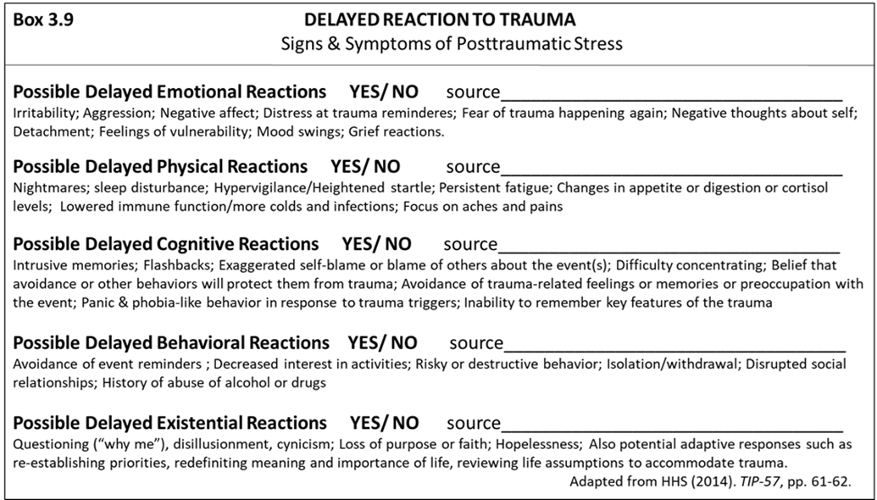
Figure: Ganzel, B., Kusmal, N., Cheatham, C., Hector, P. & Clarke, D. (accepted). Trauma-informed long-term care. In R. Perley (ed.), Managing the Long-Term Care Facility: Practical approaches to providing quality care (2nd Edition, Chapter 3). John Wiley and Sons.
FICA Spiritual History Tool is to be used as a guide to aid and open discussion to spiritual issues, not a checklist.
F - Faith and Belief
- "Do you consider yourself spiritual or religious?" or "Is spirituality something important to you” or “Do you have spiritual beliefs that help you cope with stress/ difficult times?“ "What gives your life meaning?"
I - Importance
- "What importance does your spirituality have in our life? Has your spirituality influenced how you take care of yourself, your health? Does your spirituality influence you in your healthcare decision making? (e.g. advance directives, treatment, etc.)
C - Community
- "Are you part of a spiritual community? Communities such as churches, temples, and mosques, or a group of like-minded friends, family, or yoga can serve as strong support systems for some people.” “Is this community of support to you and how? Is there a group of people you really love or who are important to you?"
A - Address in Care
- "How would you like me to address these issues in your healthcare?"

© Copyright, Christina M. Puchalski, MD, 1996
Citation: Puchalski, C., & Romer, A. L. (2000). Taking a spiritual history allows clinicians to understand patients more fully. Journal of palliative medicine, 3(1) 129-137.

EMDR Training and Certification: Eye Movement Desensitization and Reprocessing (EMDR) therapy is an extensively researched, effective psychotherapy method proven to help people recover from trauma and other distressing life experiences, including PTSD, anxiety, depression, and panic disorders.
EMDR Therapy is a recognized effective treatment for post-traumatic stress disorder (PTSD) and it has been endorsed as an effective therapy by many organizations including the Department of Veterans Affairs, the World Health Organization, and the American Psychiatric Association. Further information on training available and the certification process can be found on the EMDR International Association website.
PTSD: For further guidance refer to Caring for Veterans with Posttraumatic Stress Disorder at the End of Life: Tips for Recognizing Trauma-Related Symptoms on the WHV TIC Resource Page. If further help is needed refer to VA PTSD Consultation Program for Providers which includes experienced senior psychologists, psychiatrists, pharmacists, and other health professionals who treat Veterans with PTSD and are available to consult on everything from specific case instances to general questions. Call (866) 948-7880 or consider a telemental health visit by a VA Psychologist if the Veteran is enrolled.
VA offers telehealth services across the U.S. — including via VA Video Connect app. Veterans will need to be enrolled to receive VA telehealth services which can be initiated online at the link below or by calling 877-222-VETS (8387). https://www.va.gov/healthbenefits/online/. Telemental Health Hubs connect mental health specialists with Veterans at sites who require same-day or urgent access to mental health services. www.telehealth.va.gov.

Empathy Blocks include things like advising, interrogating, educating, judging, correcting, labeling, reassuring, etc. Examples include:

Advising: You really need to…
Interrogating: How did this happen?
Story Telling: This reminds me of…
Educating: Eating a healthy diet will help.
Sympathizing: I feel so badly for you.
Diagnosing: It sounds like you’re depressed.
Judging: What a mess this is.
Correcting: No, that’s not what happened.
One-upping: If you think that’s bad, wait until you hear this.
Reassuring: Everything is going to be just fine.
Denial of Feelings: Don’t be sad.
Minimizing: This isn’t that bad.
Blaming: This is your fault.
Criticizing: If you took better care of yourself, this would not have happened
Labeling: Because you are an Asian woman...
Analyzing: He treats me like that because he has no boundaries
Consoling: Don’t worry you will be ok.
Shutting Down: Don’t think about it. Be happy.
Explaining: The reason why I’m telling you this is so you will be more compliant with treatment.
Courtesy of Paige Hector, LMSW and Melanie Sears, RN, MBA, PhD

Stepwise Approach to address PTSD Symptoms:
A useful approach to address PTSD in Hospice Care is the Stepwise Psychosocial Staged Model for Treating PTSD at the End of Life – A Patient Centered Approach. There are three stages to this model and treatment only moves on to the next stage if symptoms are not resolved and the Veteran would like additional treatment.
Stage I: Palliate immediate discomfort and provide social supports
Stage II: Enhance coping skills
Stage III: Treat specific trauma issues

Stage 1 Example: A hospice nurse went to complete the initial intake with a Veteran referred for home hospice. Upon arriving his wife shared with the nurse that he has battled chronic PTSD since returning from Vietnam and has difficulty trusting other people.
Stage 1 Approach: Stage one of the model aims to palliate immediate discomfort, provide social support and psychoeducation. Stage one targets what can be done in terms of the environment, relational, and related interventions that facilitate comfort. For example, in terms of environment the hospice team would want to help facilitate a relaxed environment that could be done with thoughtful scheduling of providers, not having an influx of providers in a short period of time. Engaging in relational techniques such as “ask” instead of “tell,” explaining purpose of visit and procedures, and remaining accountable would all help to build trust. Incorporating interventions into the care plan that provide psychoeducation and avoid triggering of symptoms are other ways to address care needs.

Stage 2 Example: As the hospice care team worked with the Veteran, he began having significant difficulty with increased anxiety upon wakening early in the morning and finding himself alone. He had previously completed trauma treatment. The LCSW was able to review the coping skills he had previously learned during treatment and found helpful. He successfully incorporated relaxation and breathing exercises into his routine. His family was alerted to increase frequency checks to provide additional reassurance and comfort if they found him awake.
Stage 2 Approach: Interventions to Enhance Coping Skills
- Relaxation and breathing re-training
- Sleep apps
- Thought-stopping skills
- Mindfulness-based/acceptance skills
- Problem-solving interventions
- Communication/social-skills training
- Psychoeducation regarding coping skills for PTSD symptoms with patient and family

Stage 3 Example: As his health declines, his symptoms appear to be worsening. He would like to engage in psychotherapy and at this point in his disease progression he is able to participate in individual sessions but would prefer telehealth.
While many symptoms are successfully managed using techniques from the first two stages, if the Veteran desires further intervention, this is the point in the model that a hospice agency would refer to another provider trained in evidence based treatments for PTSD if they do not have one on staff.
Stage 3 Approach: Referral to Treat Specific Trauma Concerns
- Apply traditional recommended exposure-based methods if appropriate given prognosis and energy level.
- Telehealth options
- Modified EMDR – “On-the-spot”
- “Life-review-based” exposure approach
- Spiritually oriented psychotherapy
- Complementary and Alternative approaches

Sorocco and Bratkovich (2018); Feldman.B., Sorocco, Bratkovich (2014); Based on Hyer & Woods (1998)

The Stress First Aid Model:
Stress first aid is a model that was developed in military settings to help service members have better self-care and provide peer support to each other. It has applicability in hospice and palliative care settings with Veterans because the actions of stress for state are simple and very much tailored towards military culture.
Stress First Aid is based on research literature that says that people tend to do better when they feel safe, are able to calm themselves, feel connected to others, feel like they can get through what they're having to deal with, or have a sense of hope.
Stress First Aid maps onto these five elements, and adds two more, check and coordinate because it is a long-term model that starts with assessing ourselves and others (check) and may require coordinating with others in order to access other resources and support progress or recovery:
- Check should be continuous, and it involves observing, paying attention, and checking in on people on a regular basis.
- Coordinate should also be continuous, and it involves always being aware of additional resources that you may need to refer to, if your SFA actions aren’t sufficient to make a difference in alleviating stress reactions.
- Cover maps onto helping a person feel safer.
- Calm involves calming the person down or staying calm through an extended difficult experience.
- Connect involves helping a person feel a greater sense of connection to others, which may be peers, mentors, or family members. This is important because when people are stressed or responding to moral injury or PTSD, they often isolate themselves from others, and remove the possibility of social support, which of been shown to be very helpful in recovery from many types of stress.
- Competence involves helping a person feel more capable in a number of different ways, including feeling more capable to handle their own stress reactions, or feeling better able to function and recover from stressful situations.
- The last element is Confidence, which maps onto helping people have more hope or Confidence in themselves, life, or their spiritual beliefs or values. It may involve helping reduce their sense of guilt or shame, or philosophical questions that arise as a result of the stressors in their life.
- This diagram makes it seem like these actions are sequential, but in actuality, Check and Coordinate are continuous, and the others are only used as needed.
- The goal of SFA is to move people towards wellness.

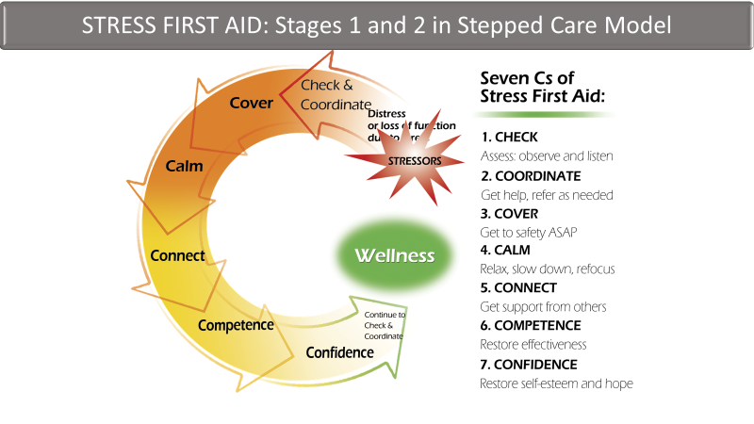

Trauma Reactions and Symptoms:
Immediate Emotional Reactions  - Numbness and detachment  - Anxiety or severe fear  - Guilt (including survivor guilt)  - Exhilaration as a result of surviving  - Anger  - Sadness  - Helplessness  - Feeling unreal; depersonalization (e.g., feeling as if you are watching yourself)  - Disorientation  - Feeling out of control  - Denial  - Constriction of feelings  - Feeling overwhelmed | Delayed Emotional Reactions  - Irritability and/or hostility  - Depression  - Mood swings, instability  - Anxiety (e.g., phobia, generalized anxiety)  - Fear of trauma recurrence  - Grief reactions  - Shame  - Feelings of fragility and/or vulnerability  - Emotional detachment from anything that requires emotional reactions (e.g., significant and/or family relationships, conversations about self, discussion of traumatic events or reactions to them)
Immediate Physical Reactions  - Nausea and/or gastrointestinal distress  - Sweating or shivering  - Faintness  - Muscle tremors or uncontrollable shaking  - Elevated heartbeat, respiration, and blood pressure  - Extreme fatigue or exhaustion  - Greater startle responses  - Depersonalization | Delayed Physical Reactions  - Sleep disturbances, nightmares  - Somatization (e.g., increased focus on and  - worry about body aches and pains)  - Appetite and digestive changes  - Lowered resistance to colds and infection  - Persistent fatigue  - Elevated cortisol levels  - Hyperarousal  - Long-term health effects including heart, liver, autoimmune, and chronic obstructive pulmonary disease
Immediate Cognitive Reactions  - Difficulty concentrating  - Rumination or racing thoughts (e.g., replaying the traumatic event over and over again)  - Distortion of time and space (e.g., traumatic event may be perceived as if it was happening in slow motion, or a few seconds can be perceived as minutes)  - Memory problems (e.g., not being able to recall important aspects of the trauma)  - Strong identification with victims | Delayed Cognitive Reactions  - Intrusive memories or flashbacks  - Reactivation of previous traumatic events  - Self-blame  - Preoccupation with event  - Difficulty making decisions  - Magical thinking: belief that certain behaviors, including avoidant behavior, will protect against future trauma  - Belief that feelings or memories are dangerous  - Generalization of triggers (e.g., a person who experiences a home invasion during the daytime may avoid being alone during the day)  - Suicidal thinking
Immediate Behavioral Reactions  - Startled reaction  - Restlessness  - Sleep and appetite disturbances  - Difficulty expressing oneself  - Argumentative behavior  - Increased use of alcohol, drugs, and tobacco  - Withdrawal and apathy  - Avoidant behaviors | Delayed Behavioral Reactions  - Avoidance of event reminders  - Social relationship disturbances  - Decreased activity level  - Engagement in high-risk behaviors  - Increased use of alcohol and drugs  - Withdrawal
Immediate Existential Reactions  - Intense use of prayer  - Restoration of faith in the goodness of others (e.g., receiving help from others)  - Loss of self-efficacy  - Despair about humanity, particularly if the event was intentional  - Immediate disruption of life assumptions (e.g., fairness, safety, goodness, predictability of life) | Delayed Existential Reactions  - Questioning (e.g., “Why me?”)  - Increased cynicism, disillusionment  - Increased self-confidence (e.g., “If I can survive this, I can survive anything”)  - Loss of purpose  - Renewed faith  - Hopelessness  - Reestablishing priorities  - Redefining meaning and importance of life  - Reworking life’s assumptions to accommodate the trauma (e.g., taking a self-defense class to reestablish a sense of safety)
Sources: Briere & Scott, 2006b; Foa, Stein, & McFarlane, 2006; Pietrzak, Goldstein, Southwick, &
Grant, 2011.

Substance Abuse and Mental Health Services Administration. Trauma-Informed Care in Behavioral Health Services. Treatment Improvement Protocol (TIP) Series 57. HHS PublicationNo. (SMA) 13-4801. Rockville, MD: Substance Abuse and Mental Health Services Administration, 2014.

