**Veteran Volunteer Highlights**

**During the Covid-19 pandemic we have had several volunteers step up and think outside of the box to be able to continue to provide the best care for our patients. Several of our Vet-to-Vet volunteers decided to make weekly phone calls to our veterans and their families to just check in, offer support and keep in touch when they could not safely visit in person. Our patients and volunteers were so thankful to be able to do this.**

**Veterans in the numbers**

**During 2019/2020 Ballad Health Hospice served 176 Veterans. We are honored to be able to provide them dignified care in their final days.**

**Outside of the requirement**

**Several staff and volunteers take part in the webinar “Faith Communities as Partners in Veteran Care” which was provided by our local Mountain Home VA.**

**Even during the pandemic our staff and volunteers provided Veterans’ Spouses’ Day, Fourth of July, and Veteran’s Day gifts to all of our veterans.**

**In the NEWS!**

**During 2019 and 2020 with the assistance of our local State Representative office we were able to offer all of our veterans the opportunity to be part of the Veterans History Project through the Library of Congress. We had 4 veterans who participated in the program with the assistance of our volunteer coordinator. Thanks to this program, their families and others will be able to access their stories for years to come.**

**Best moments from Level 5**

**My favorite memory is the son and father sharing together at a Vet-to-Vet Café. The son brought his father who is currently on hospice. They were able to share freely their experiences together as they were both veterans. It was one of the best cafes we have had.**

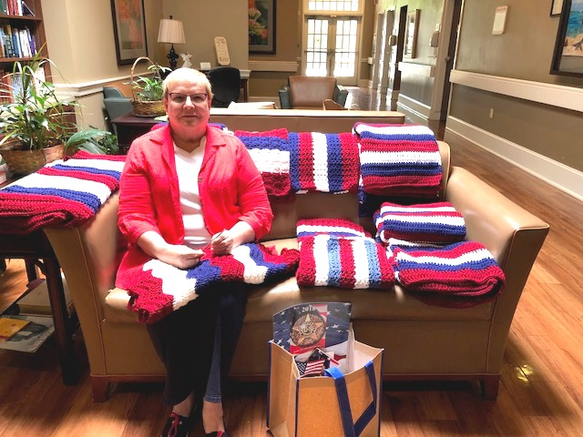 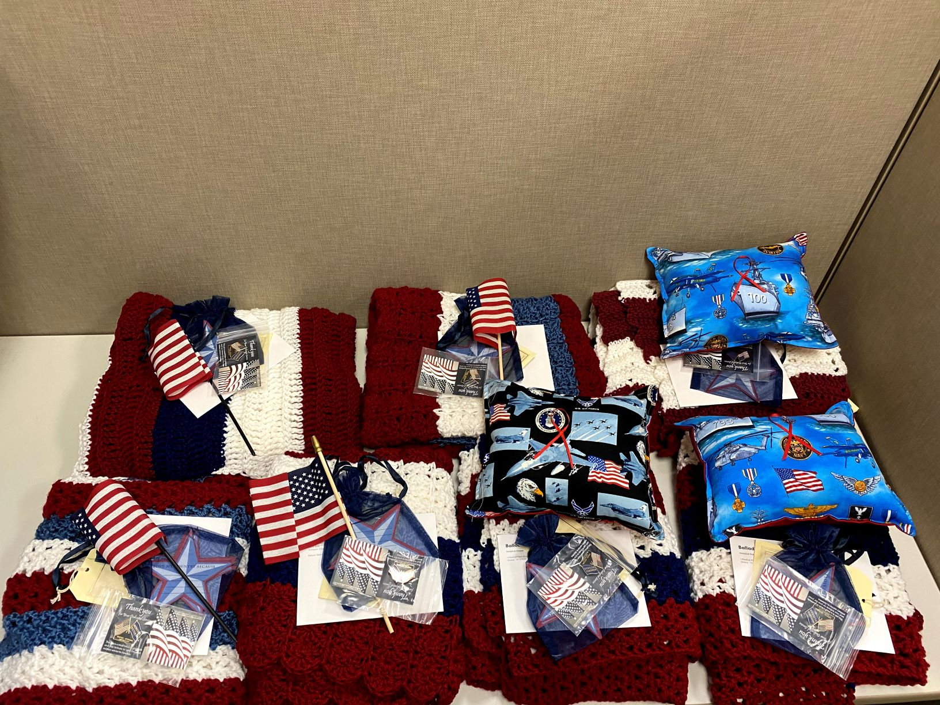

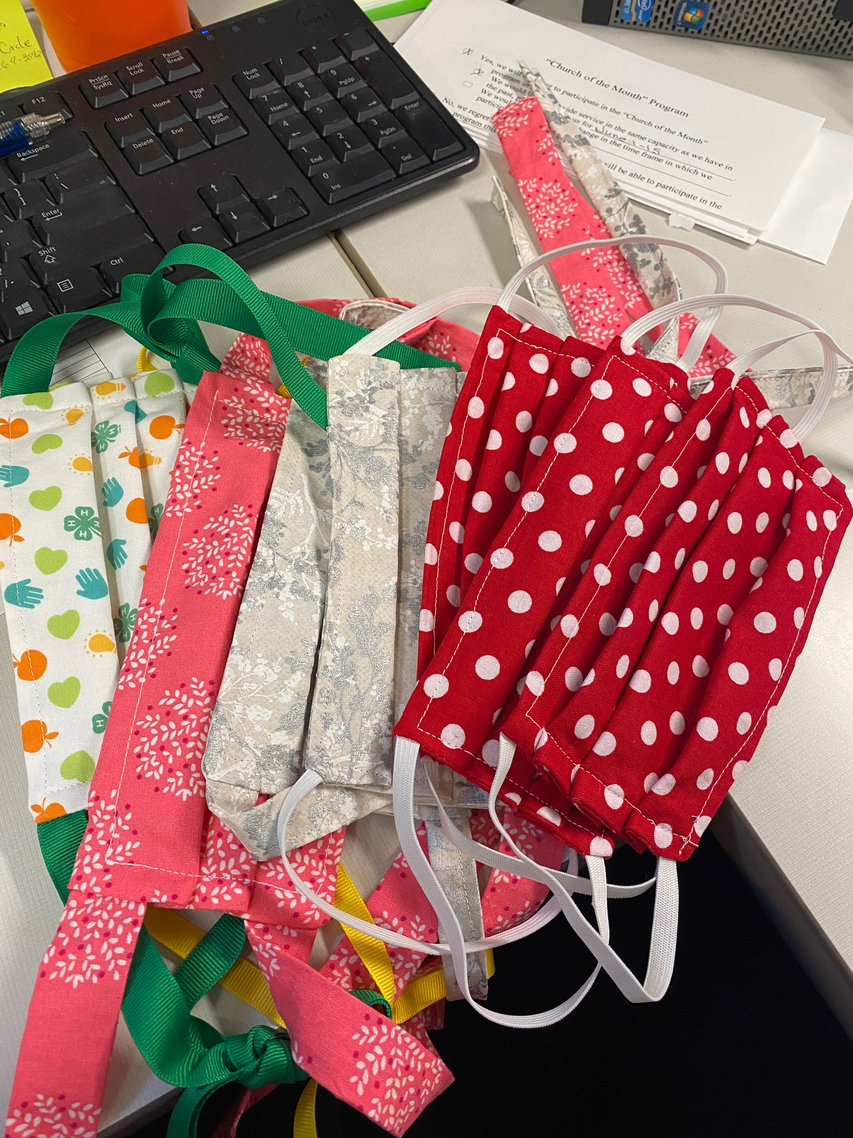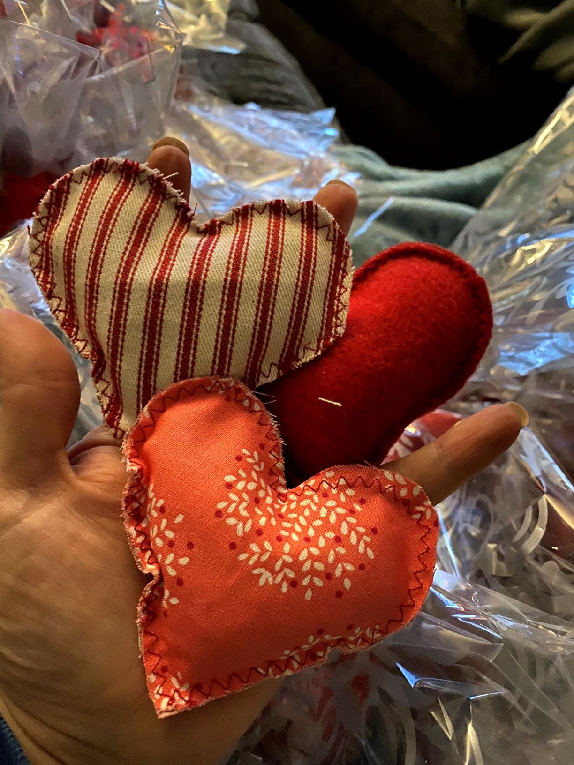

**Our volunteers became very crafty this year due to not being able to visit patients in person regularly. They made masks, blankets, pillows, and hand warmers for our veterans and their families. It was a nice way for them to know they cared even when they couldn’t visit them in person.**