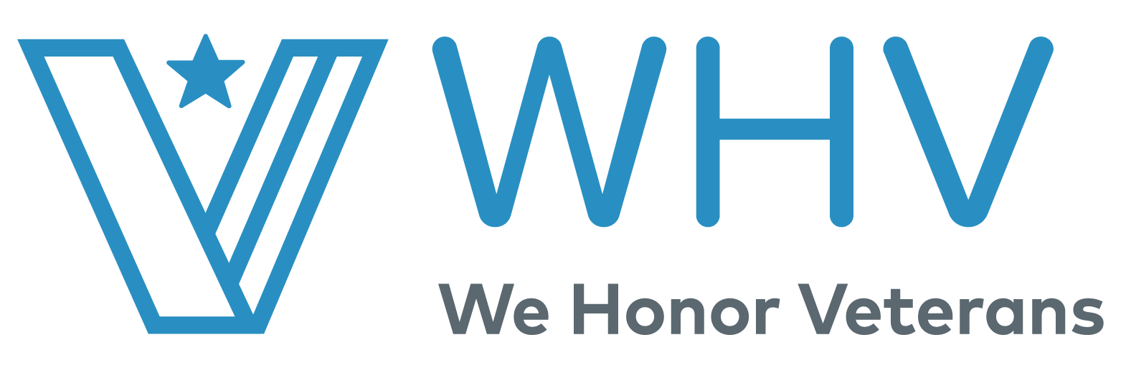

We Honor Veterans Level 5 Partners Activities.

Educational Requirements
Required Activity | Notes | Partner Activities
Continue to integrate Veteran-specific content into staff and volunteer orientations and ongoing trainings. These trainings can be completed virtually with your staff. | Include presentations, frequency and number of staff + volunteer participants  (VA webinars, presentations/webinars spread out throughout the year, integrate presentations into meetings).
Include PsychArmor’s “15 Things Veterans Want You To Know” in staff trainings.  https://psycharmor.org/courses/15-things-veterans-want-you-to-know/ | Include frequency of orientation and number of staff and volunteers oriented over the last year.  *Every staff and volunteer must complete*
Have a VA Accredited Agent on staff and/or relationship with Veteran Service Officer, have updated VA Fact Sheet available  https://www.wehonorveterans.org/resource-library/va-fact-sheet-for-hospice-partners/  You can complete this activity by hosting a virtual meeting with your accredited agent and or Veteran Service Officer. | If you do not have an Accredited Agent on staff, please describe relationship with VSO.  *Please see FAQ for more information*
Vietnam Veterans-focused training  All staff are required to watch all 3 specific VA Vietnam Veteran Trainings webinars.  - Posttraumatic Stress Disorder in Vietnam Veterans  - Suicide Prevention in Vietnam Veterans  - Moral Injury in Vietnam Veterans | Describe resources and trainings used specifically for the care of Vietnam Veterans. Please include details on or attach any resources you use.  Please track the 3 specific trainings in the excel workbook under the sheet labeled “Vietnam Veterans”
Include Veteran Certificates & Pinning Ceremony Procedure into staff and volunteer orientation as well as Welcome Home Ceremony for Vietnam Veterans (yellow, red and green beads). Have the Vietnam Veteran beads made available.  Virtual pinning’s are encouraged, if you want to learn more about honoring during COVID-19 follow the link here. | Describe any pinning and recognition ceremonies including number of Veterans pinned.  Please see the FAQ for further instructions on the beads.  If the Vietnam Veteran does not want to make the beads, you can have a Veteran volunteer make them for distribution.
In collaboration with your HVP, conduct at least 3 virtual community events; at least one must include a panel discussion. These events can also be focused on community service activities and support for Veterans in your area. Examples of community service activities can range from making COVID-19 care packages for local Veterans or hosting a socially distant Veterans Stand Down or cafe. | Describe community events, including participants. Include recognition/celebrations to an invisible population (local homeless shelter), or other space for Veterans to gather (ex: “Lunch & Learn”). For suggestions of community service activities please see the updated FAQ page.
Vet-to-Vet Cafes https://www.wehonorveterans.org/resource-library/veteran-to-veteran-cafe-planning-tool/ | Hold Vet-to-Vet Cafes at least quarterly, include details on activities and stories of participation.  If your calendar does not allow for quarterly Cafes, you can distribute throughout the year. You must complete at least 4, per year. These Vet-to-Vet Cafes can also be a social gathering not including coffee.  These can be held online or conducted while using social distanced protocols. You can find examples of a Vet to Vet Cafes in the in the FAQ document.
Review NHPCO Standards of Practice for Hospice Programs (2019) | Review with staff and volunteers on an ongoing schedule. Encouraged Quarterly. As well, comment on what you’ve learned.  Include number of staff that view the Standards of Practice.  Reviewing of the standards can be down virtually with staff.

Veteran-to-Veteran Volunteer Program
Required Activity | Notes | Partner Activities
Hospice must have Vet-to-Vet volunteers: include number of volunteers, orientation process and activities. Please keep in mind hospice volunteer training isn’t necessary for Veteran volunteers who are supporting in other ways (writing letters, quilt making etc). | Include number of volunteers, orientation process, and activities.  Although partners are encouraged to continue working with Vet-to-Vet volunteers we want to acknowledge the current situation with COVID-19. You can have your Veteran volunteers support in other ways such as quilt making and writing Vet-to-Vet letters.

Care Planning Guide for Veterans
Required Activity | Notes | Partner Activities
Implement Veteran-specific tool or procedures in initial assessment | View the care planning guide for Veterans to further educate staff and develop care plan (template attached, adjust as needed); include pre-education and education of concepts within process.  It can be found attached.  Include a paragraph of what you learned in the partner activities section. Also include the following information.  - How many patients are you using the plan of care with? (must be completed with every Veteran) *Especially for your Vietnam and Combat Veterans*  - If applicable include anything else that comes up under “other patient specific”

Data Collection * For all numbers within the activities were asking please provide it through this spreadsheet. Please feel free to add additional data if you feel necessary. *Please do not send patient names as it is violation of HIPAA regulations*

Required Activity | Notes | Partner Activities
Summary Report on data collected will be turned in at the end of the year | Include (at a minimum) the following:  - Number of Veterans Served During Timeframe  - Period of Service Breakdown  - Number Enrolled in VA prior to admission  - Number Receiving VA Benefits at time of admission  - Number who requested and assisted enrolling in benefits at time of admission  - Who refuse or declined VBA benefits  Vietnam Veterans (excel sheet 4)  - How many Vietnam Veterans have been treated for the following? (Moral Injury, PTSD, Suicide Prevention) | Please collect all data in the excel workbook provided

Commitment to Being a Regional WHV Mentor
Required Activity | Notes | Partner Activities
Partners will be listed as a mentor on the WHV website/Partnership Directory | Include information (email) of organizational contact, listing on directory will also include start & end date of Level 5. If you’re already a completed level 5 partner, please include the following:  - How many partners reached out to you?  - Have you noticed any common themes or frequently asked questions?

Annual Report
Required Activity | Notes | Partner Activities
Summary of previous year’s activities (communications included) | Provide highlights from previous year’s activities, this is the time to brag about anything extraordinary or out-of-the-box that your program did as a Level 5 Partner. Please include as many visuals as possible as well as written release for any photos that NHPCO can include in their materials. | The Annual report must be submitted in a PDF or Word Format following the Annual Report template provided. You can use version 1 or 2 and customize the questions and outline.

Community/State-wide Events
Required Activity | Notes | Partner Activities
Two events per year | Conduct at least two community/state-wide events. One must be a Welcome Home Vietnam Veterans Day; this event can be done virtually and can include other era-specific Veterans. The second community/state-wide event can be fulfilled by community service activities, such as making COVID-19 care packages for local Veterans or hosting a socially distant Veterans Stand Down or cafe.

